**Starting your new restaurant in Mumbai**

# Introduction

As one of the big financial hub of the world, Mumbai represents one of the most densely populated cities in the globe. As multi-cultural city, Mumbai attract so many people for either working or enjoying their holidays. For most of the times any person will find some difficulties in finding some of his preferable cuisines. Thus, the aim of this project is to study the Mumbai neighborhoods in order to determine suitable locations for new restaurant. This project can be useful for business owners and entrepreneurs who are looking to invest in a restaurant in Mumbai. Through the project, a recommendation detailed plan will be presented in order to facilitate the choice of the stakeholder.

# Data Collection

The following data is required for the project:

1. Neighborhood data of Mumbai
2. Geographical coordinates of Mumbai and all neighborhoods in Mumbai
3. Venue data for neighborhoods in Mumbai

## Neighborhoods Data

The data of the neighborhoods in Mumbai was scraped from [https://en.wikipedia.org/wiki/List_of_neighborhoods_in_Mumbai](https://en.wikipedia.org/wiki/List_of_neighbourhoods_in_Mumbai). The data is read into a pandas data frame using the read_html() method. The main reason for doing so is that the Wikipedia page provides a comprehensive and detailed table of the data which can easily be scraped using the read_html() method of pandas. The top 10 rows of the dataframe are shown in Figure 1.

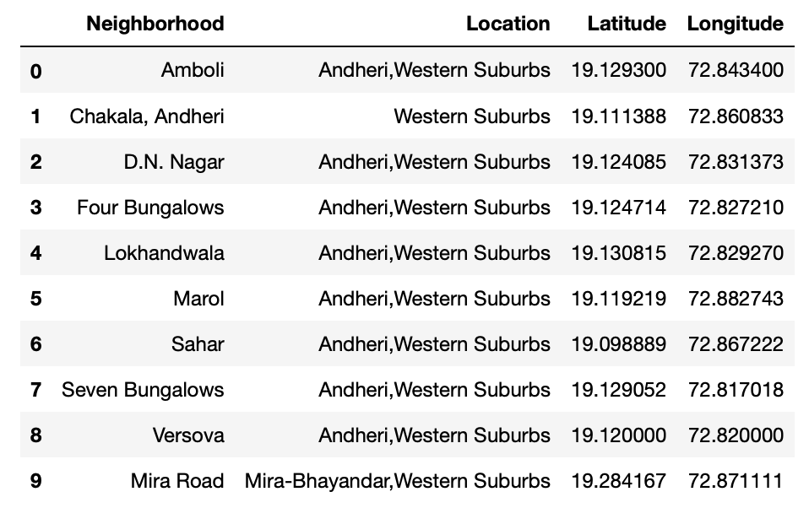

Figure 1: Top 10 rows of Mumbai neighborhoods data scraped from Wikipedia.

## Geographical Coordinates

The geographical coordinates for Mumbai has been obtained from the GeoPy library in python. This data is relevant for plotting the map of Mumbai using the Folium library in python. The code for getting the geographical coordinates of Mumbai is shown in Figure 2.

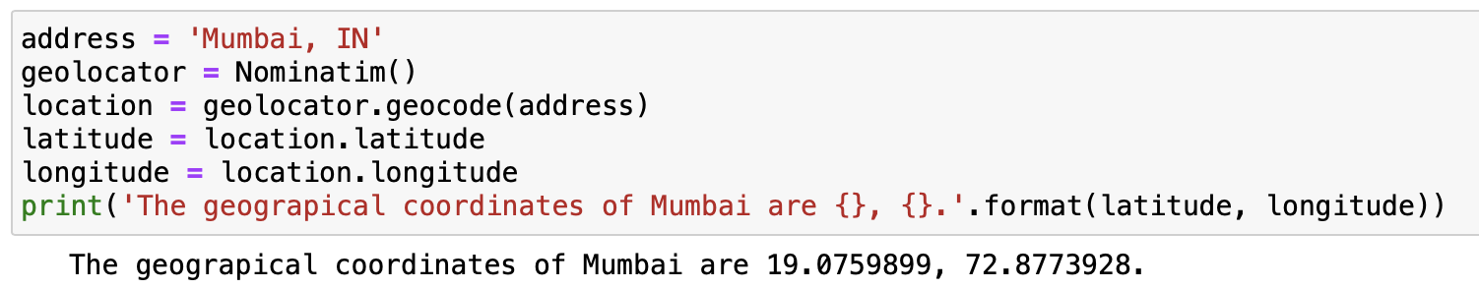

Figure 2: Obtaining geographical coordinates of Mumbai.

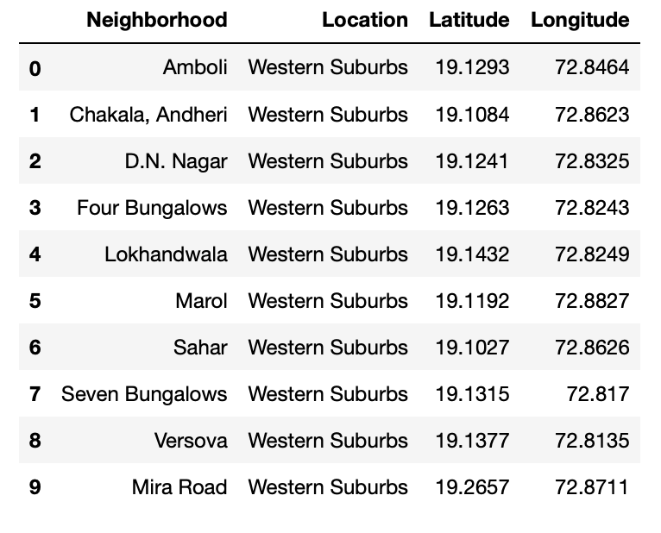

Figure 3: Final Mumbai neighborhoods dataframe.

## Venue Data

The venue data has been extracted using the Foursquare API. This data contains venue recommendations for all neighborhoods in Mumbai and is used to study the popular venues of different neighborhoods as well as build the unsupervised learning model to cluster neighborhoods. The venue recommendations of all neighborhoods were obtained with a limit of 200, that is, maximum of 200 venue recommendations per neighborhood and a radius of 1 km around the neighborhood’s geographical coordinates. Figure 4 shows the top 10 rows depicting the results obtained after cleaning the data from Foursquare API.

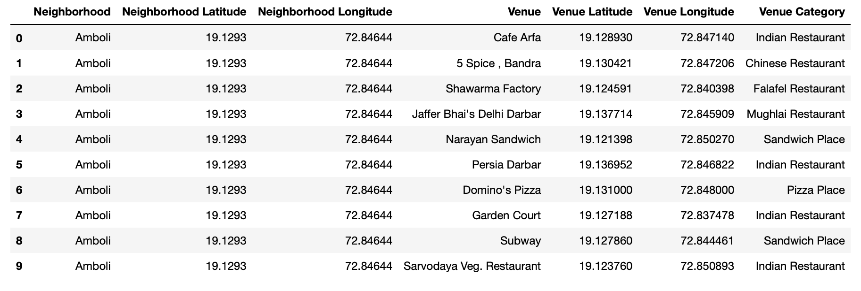

Figure 4: Data obtained from Foursquare API after cleaning.

# Methodology

This section provides details for the methodology used in the project.

## Data Visualization

In order to understand the data obtained for Mumbai neighborhoods, basic visualization was carried out. Figure 6 shows a bar plot depicting the number of neighborhoods in each location in Mumbai.

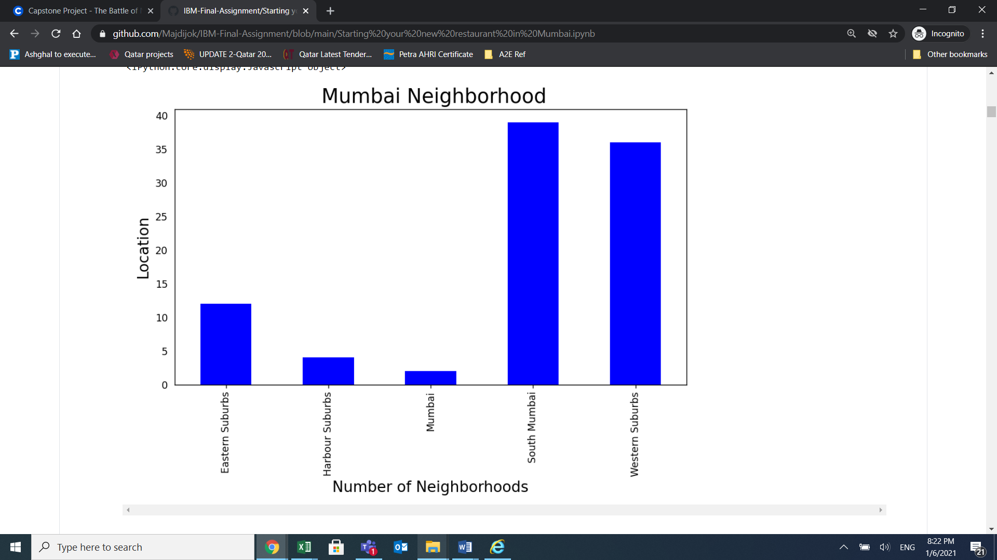

Figure 5: Number of neighborhoods grouped by location.

It is evident from Figure 5 that South Mumbai and Western Suburbs have the most number of neighborhoods. Notice how we see one of the locations as Mumbai itself? This is because the neighborhoods contained in this location are located at the outskirts of the city and thus have been termed as just Mumbai.

Results

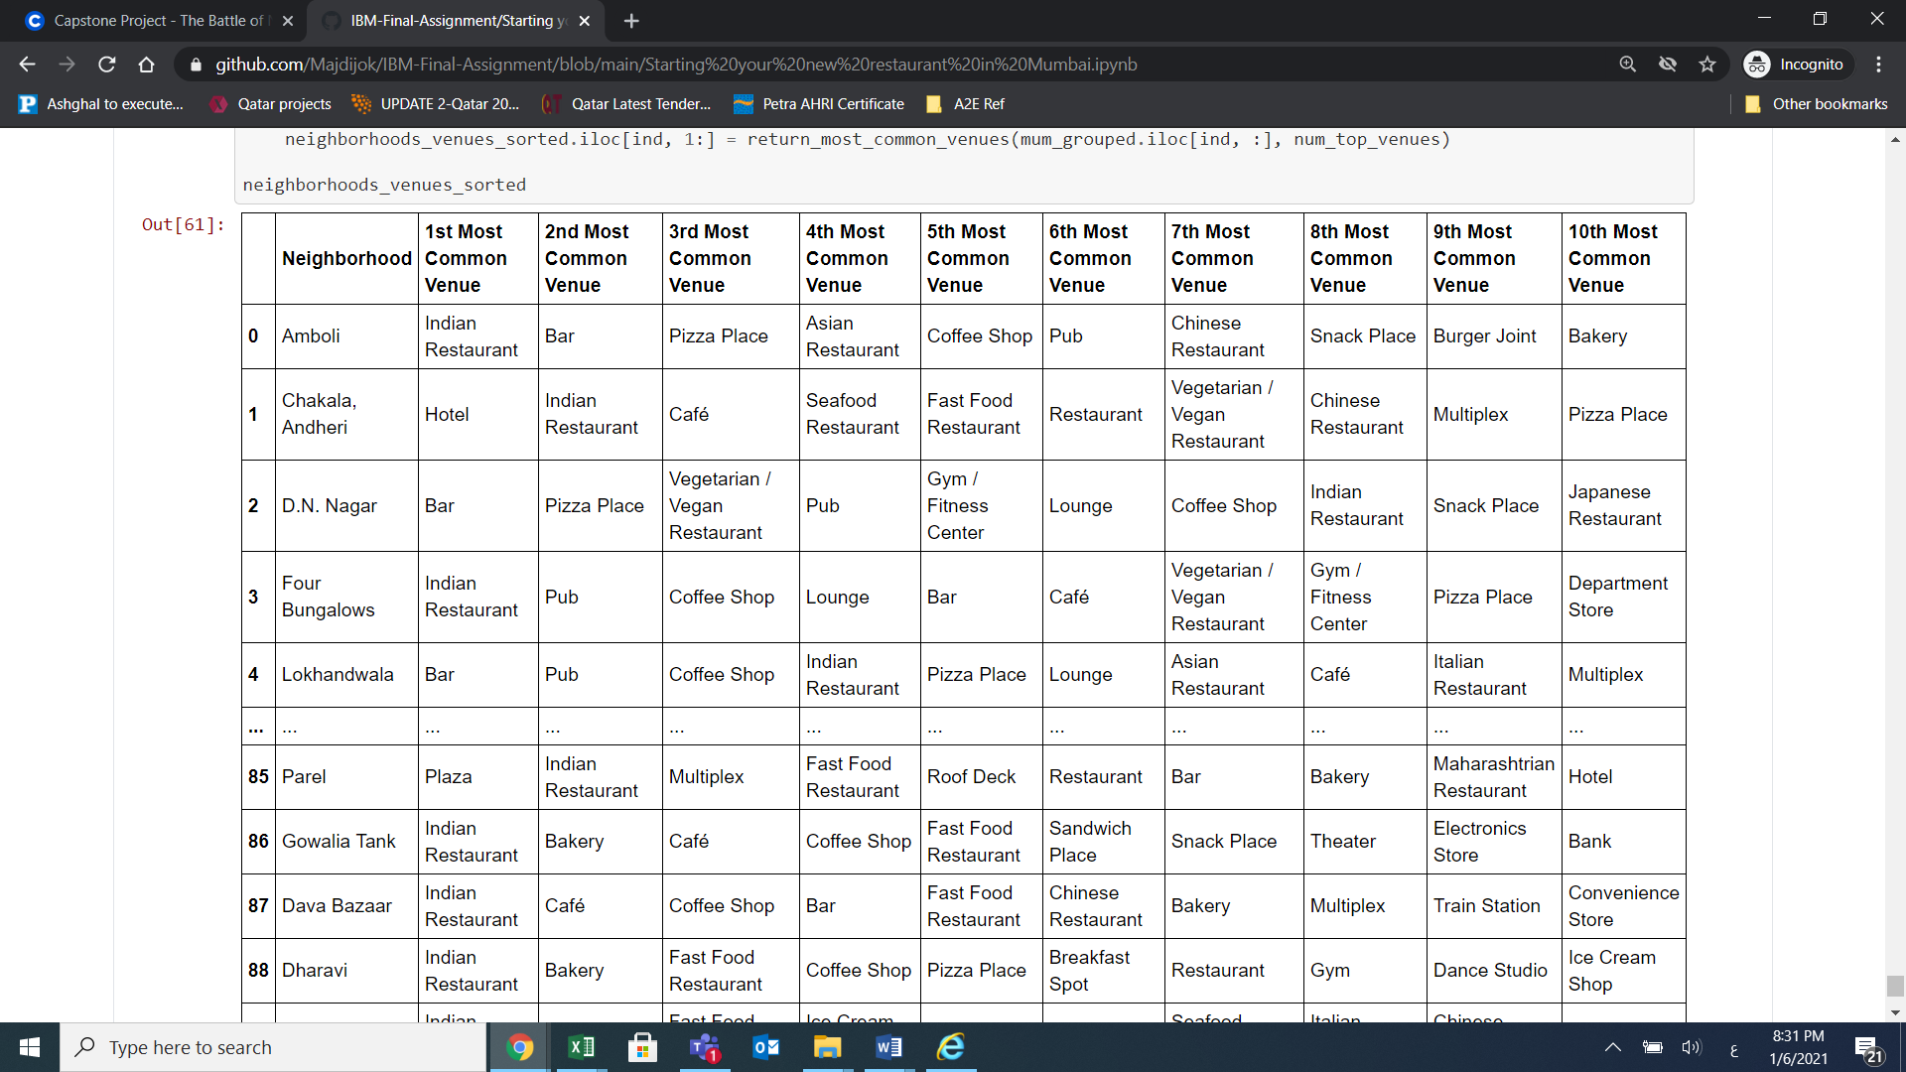

As a result we are exposing the most common venues for each neighborhood. The same would be healthy and first data driven decision making folowed process to choose the right place and type for your next restaurant.

# Discussion

Going through the provided listing investors would be able to retrieve the information required to select a specific restaurant type for specific area. The proposed solution would present a data driven solution for any investor or stakeholder to start his own business or to change his own to a new one.

# Conclusion

We have successfully analyzed the neighborhoods in Mumbai, India for determining which would be the best neighborhoods for opening a new restaurant. The stakeholders and investors can further tune this by considering various other factors like transport.